CSC8502 Coursework Support Document

Prerequisites:

Coursework Project must be set as the startup project

nclgl must be set as a dependency of the Coursework Project Solution.

Screenshots:

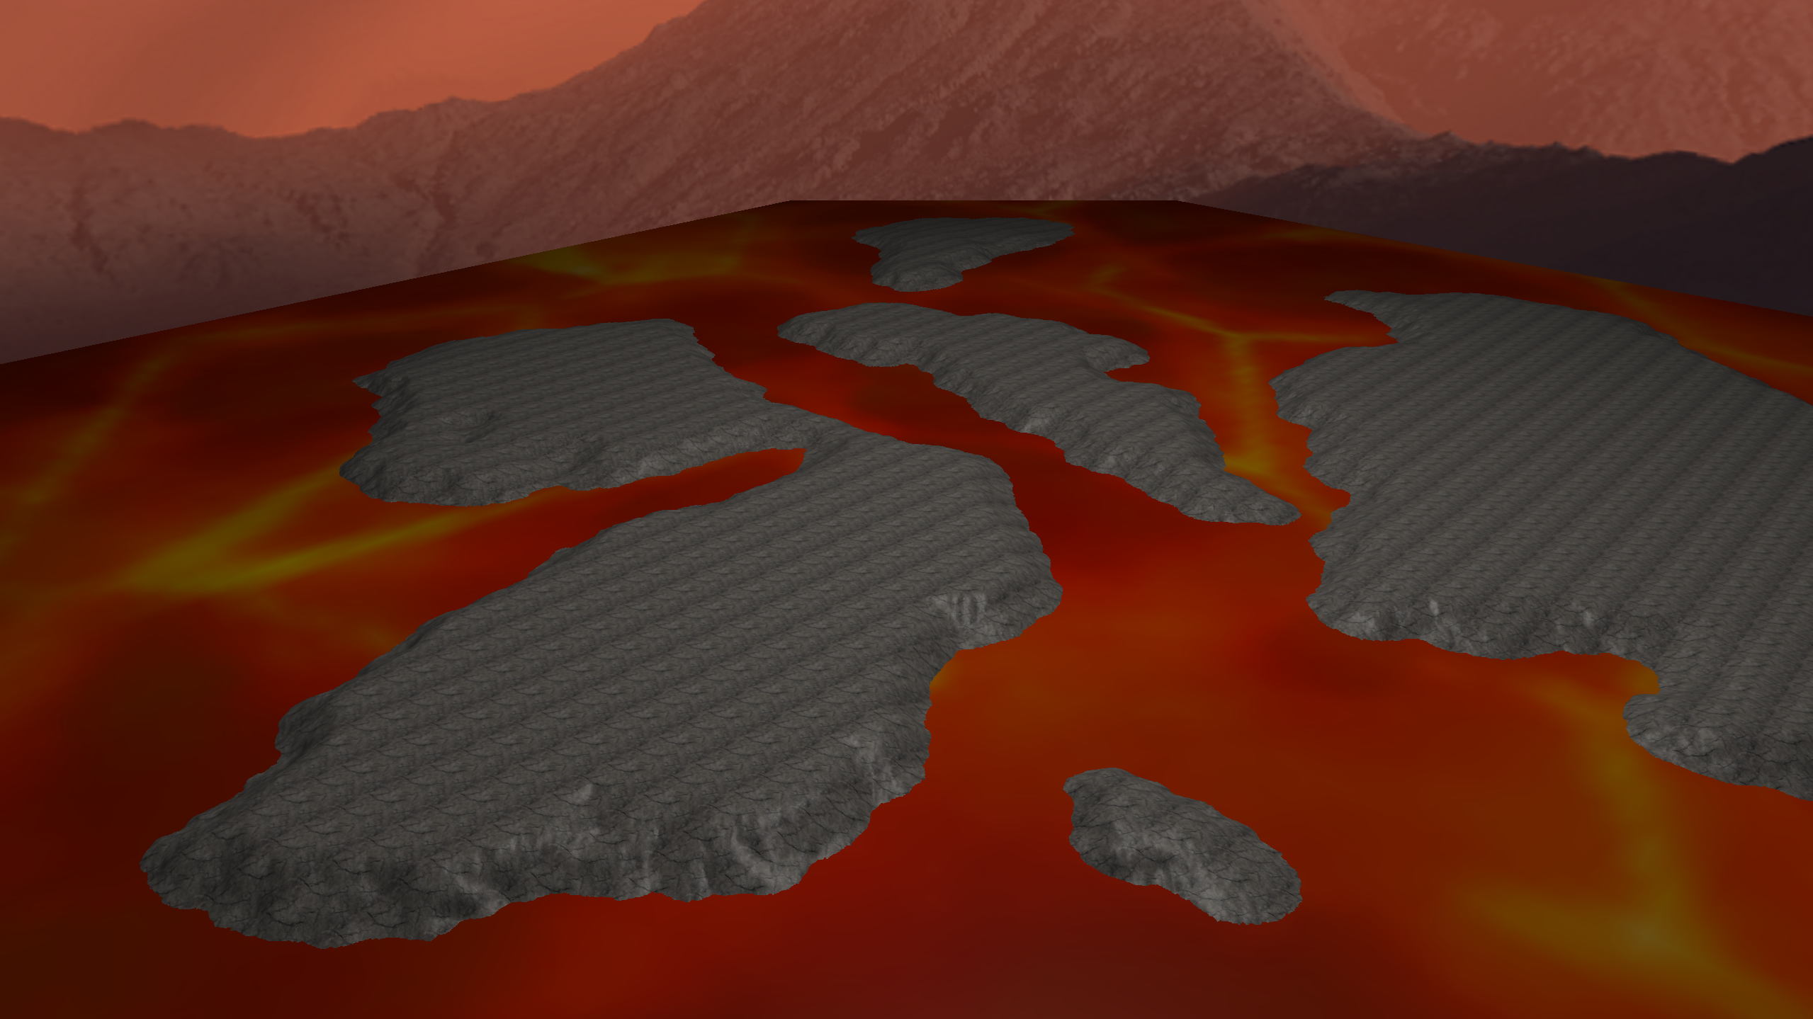

Initial scene: Earth, 4 billion years ago, when wasteland and magma made up a majority of the earth’s surface, and mountain ranges existed that would be destined to be broken apart. This scene contains a height map render of rocky barren land, with a cube map skybox of a mountain range and a simple texture of lava.

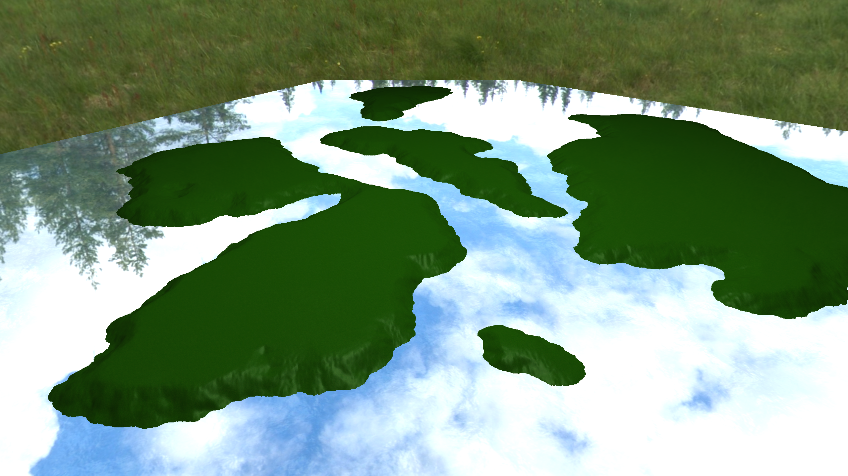

The scene transitions with a fade to black into the same land, but in the modern day, the magma has been absorbed into the ground, and the mountain ranges have made way for a field surrounded by trees and flooded by water.

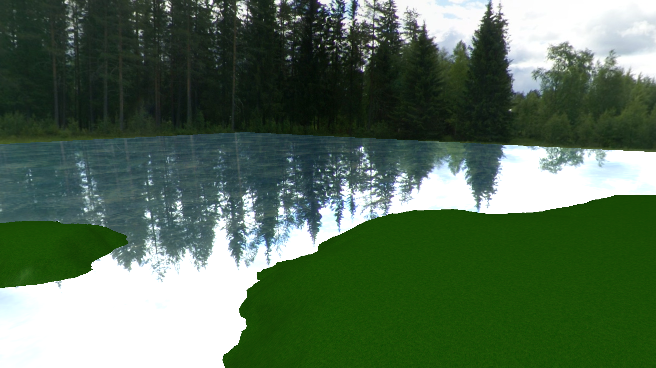

The water also interacts with light, allowing it to reflect the skybox. It also rotates to give the impression of flowing waves.

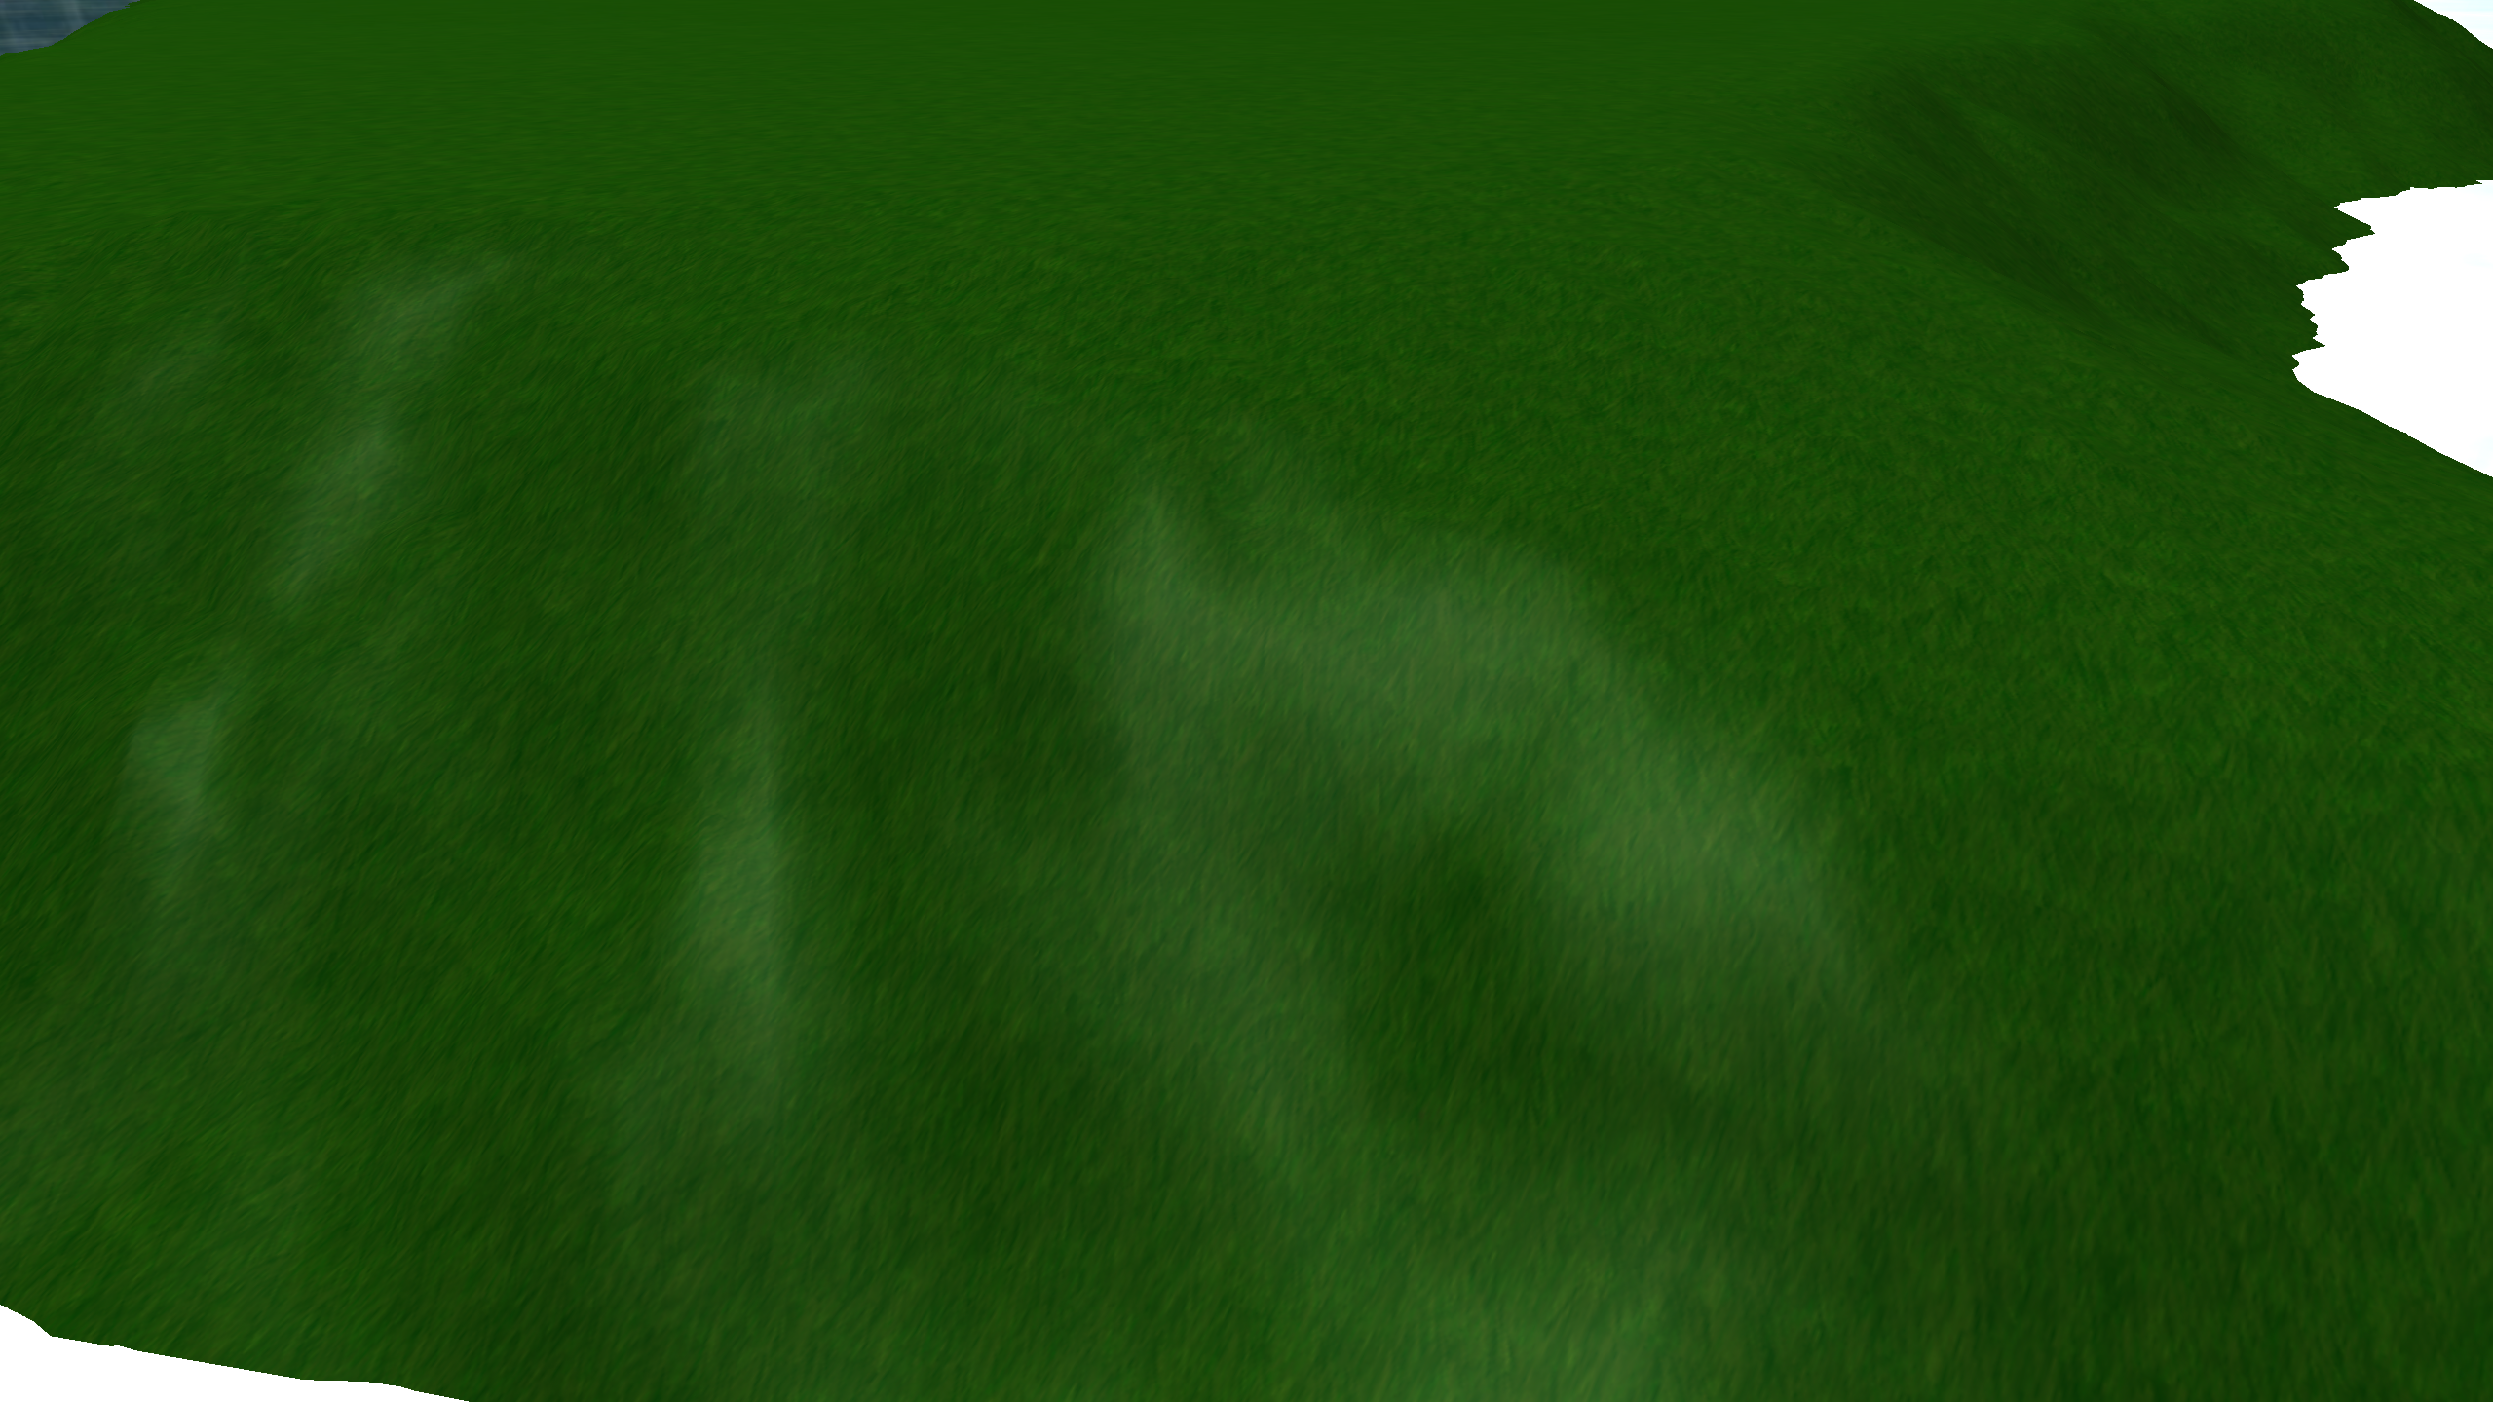

A light source is also active in the sky to mimic a sun, with ambient, diffuse and specular calculations being done so that it has a slightly more realistic appearance.

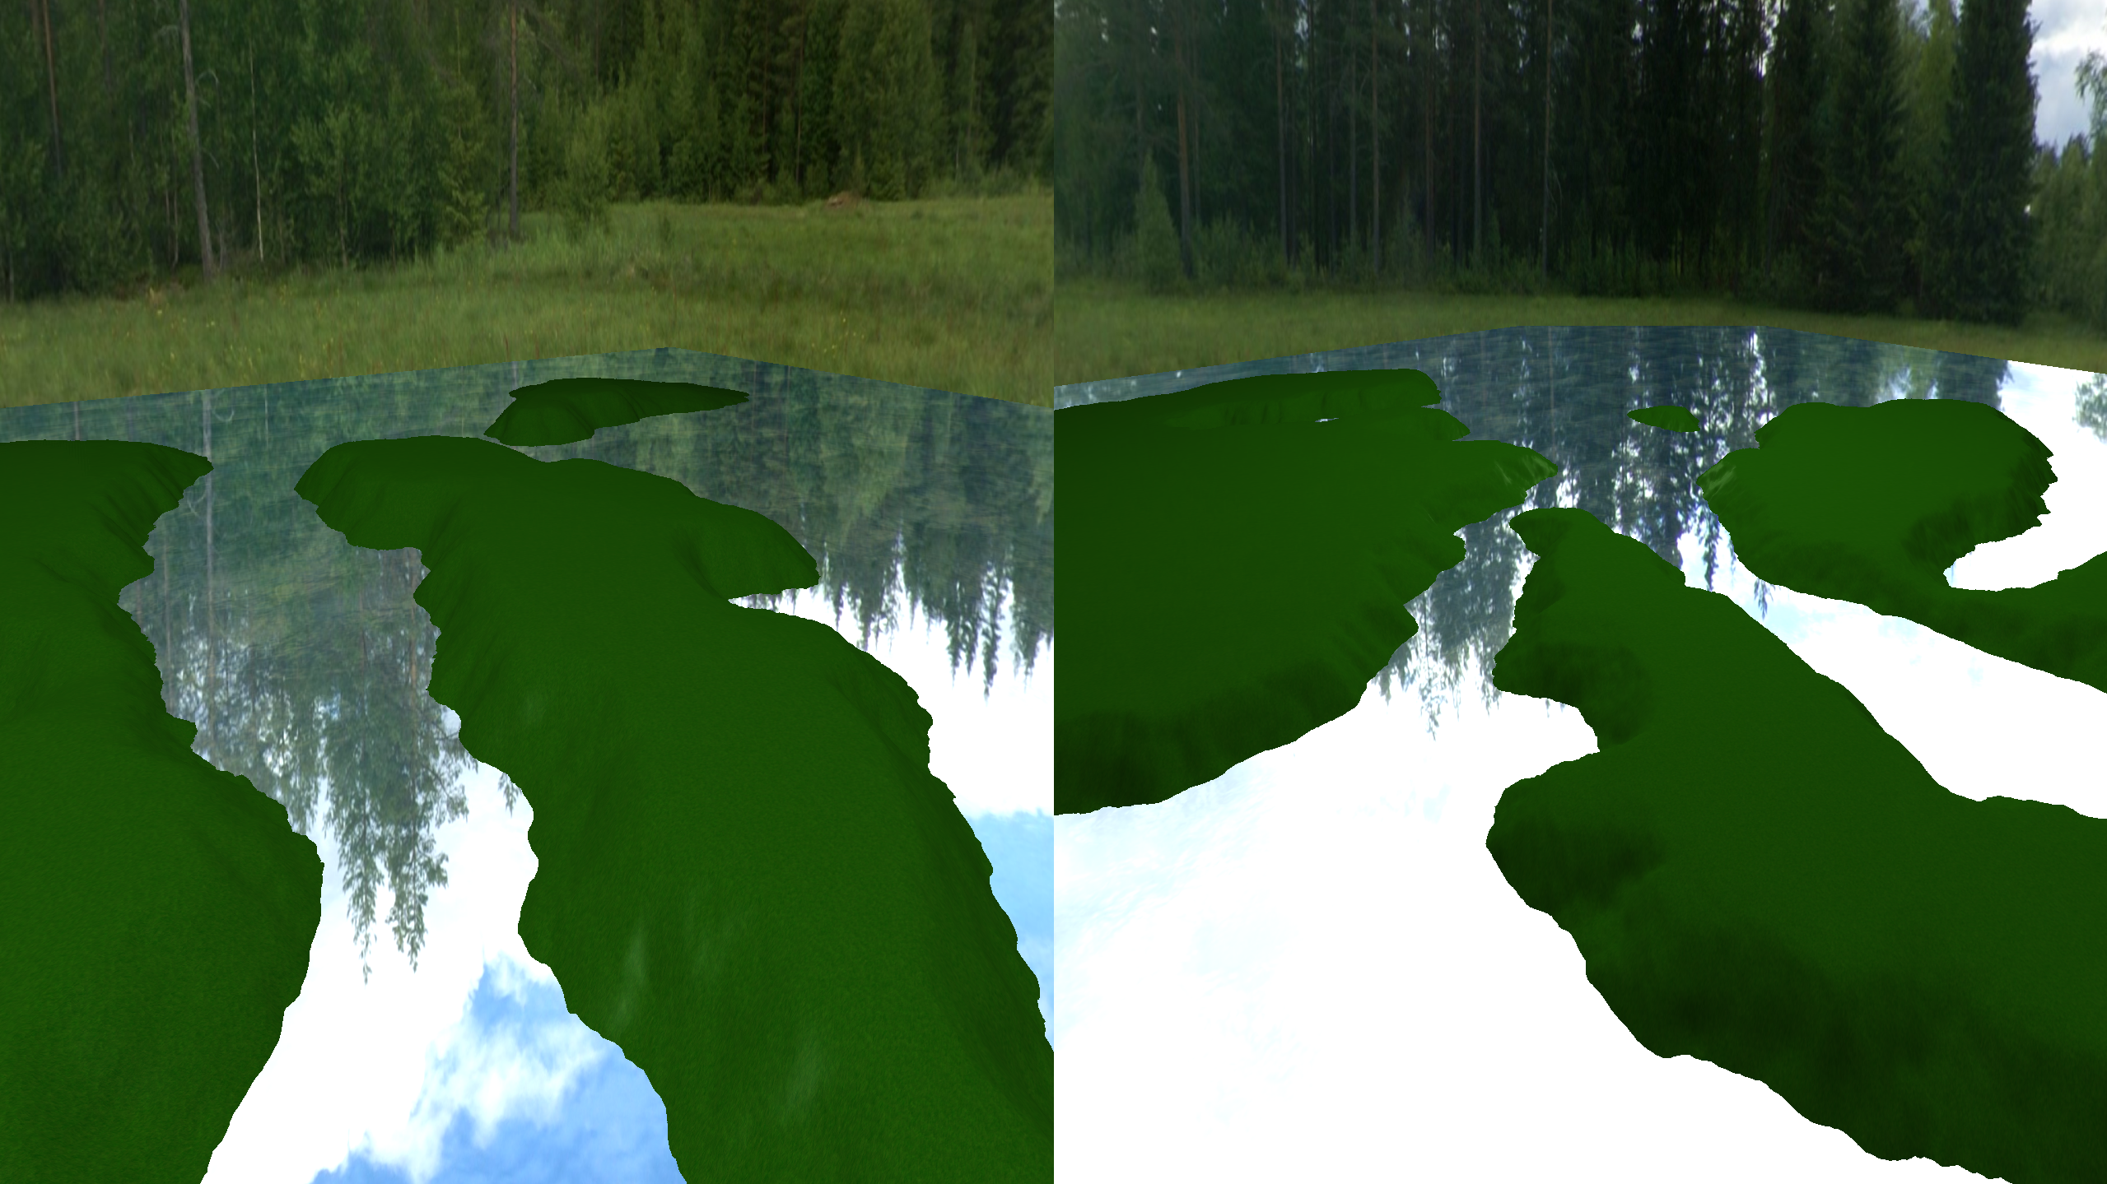

A split-screen feature has also been implemented, allowing for two unique viewpoints of the landscape at a single time.

Keyboard Inputs:

1 – Toggle between the initial scene and alternate scene (with a transition)

2 – Toggle the split-screen view

3 – Free the camera from the automated track

Link to YouTube video:

<https://youtu.be/4pLgdpI3dvo>